Promoting Youth Physical Activity
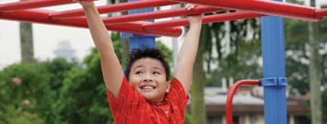
Youth gain physical and mental health benefits when they participate in regular physical activity. Schools, families, and communities can help youth be physically active and stay active throughout their lives.

Physical Activity and Youth: Be Active and Play!
Youth gain physical and mental health benefits when they participate in regular physical activity. Unfortunately, many children and adolescents do not participate in physical activity for 60 minutes or more each day, as recommended by the 2008 Physical Activity Guidelines for Americans. However, schools, families, and communities can help youth be physically active and stay active throughout their lives.

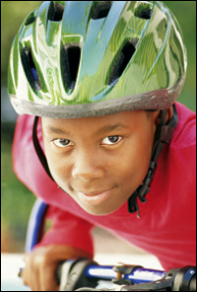

The Benefits of Youth Physical Activity
Regular physical activity in childhood and adolescence improves strength and endurance, helps build healthy bones and muscles, helps control weight, reduces anxiety and stress, increases self-esteem, and may improve blood pressure and cholesterol levels.¹ Positive experiences with physical activity at a young age also help lay the basis for being physically active throughout life.¹

How Active Are Youth?
In 2007, only 17% of high school students participated in at least 60 minutes of physical activity each day, and only 30% attended physical education class daily.³ During nonschool hours, 62% of children aged 9-13 years do not participate in any organized physical activity and 23% do not engage in any free-time physical activity.⁴ Participation in physical activity declines as children age.³ Support from friends and family and safe, convenient access to play spaces can positively influence physical activity involvement among youth.⁵ Additionally, health, education and industry leaders can help increase youth physical activity by following the U.S. National Physical Activity Plan, which is designed to create an environment in which all Americans, including youth, can be physically active where they live, work and play.

Toolkit for Helping Kids to Be Physically Active
In collaboration with several partner organizations, CDC has developed the Youth Physical Activity Guidelines Toolkit which contains the resources, strategies, and guidance necessary to inform adults about the importance of regular physical activity, the current physical activity guidelines, and ways to encourage physical activity among youth. Using video and written materials, the toolkit highlights specific strategies that schools, families, and communities can use to support youth physical activity.
Specifically, the toolkit includes the following:
- Three audience-specific fact sheets
- Video
- Poster
- User instruction guide
- Four customizable PowerPoint presentations
- Chapter 3: "Active Children and Adolescents" from the Department of Health and Human Services Guidelines document

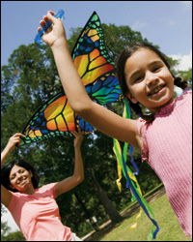

Take Action
Schools, families, and communities can play an important role in helping children and adolescents be physically active:
- Schools can establish policies that provide diverse opportunities for students to be physically active, such as required daily physical education and recess.
- Parents can model positive physical activity behaviors by leading an active lifestyle and
making "family time" physical activity time.
- Families can help children be active with their friends.
- Families can limit "screen time" (i.e., time watching TV, playing video games, or using the computer).
- Communities can conduct community-wide physical activity campaigns.
- Communities can help people find places where they can be physically active (i.e. parks, playgrounds, athletic fields).
- Families and communities can work with schools to increase youth physical activity.
To learn more about the importance of youth physical activity 1) view CDC's informational video and 2) review our fact sheet series for strategies pertaining to schools, families, and communities. Remember, these strategies are most effective when they are coordinated within schools, families, and the community.

More Information
- Youth Physical Activity Guidelines Toolkit
- 2008 Physical Activity Guidelines for Americans, Chapter 3: Active Children and Adolescents
- CDC Physical Activity Web Site
- HHS Physical Activity Guidelines Web Site
- U.S. National Physical Activity Plan

References
- U.S. Department of Health and Human Services. Physical activity guidelines advisory committee report. Washington, DC: U.S. Department of Health and Human Services, 2008.
- U.S. Department of Health and Human Services. 2008 Physical Activity Guidelines for Americans. Washington, DC: U.S. Department of Health and Human Services, 2008.
- CDC. Youth Risk Behavior Surveillance—United States, 2007 [PDF]. MMWR 2008; 57(No.SS-4).
- CDC. Physical Activity Levels Among Children Aged 9-13 Years –United States, 2002. MMWR 2003; 52(33):785-8.
- CDC. Guidelines for School and Community Programs to Promote Lifelong Physical Activity Among Young People. MMWR 1997; 46(RR-6):1-36.

